**PROJECT 3 DESIGN NOTEBOOK**

**TEAM 45**

**KATHRYN ATHERTON**

**JOSHUA HAHN**

**HANNAH MACKIN SCHENCK**

**TABLE OF CONTENTS**

|  |  |
| --- | --- |
| Meeting Agendas and Minutes | 3-8 |
| January Meetings | 3 |
| February Meetings | 3-6 |
| March Meetings | 7-8 |
| April Meetings | 8 |
| Project Scheduling, Management | 9-10 |
| Gantt Chart | 9 |
| Project Management | 9 |
| Work Breakdown Structure | 10 |
| Brainstorming | 11-15 |
| Morphological Chart | 11 |
| Design Specifications | 11-16 |
| Prototypes | 17-19 |
| Prototype I | 17 |
| Prototype II | 18-19 |
| Flowcharts and QFDs | 20-21 |
| Functional Block Diagram | 20 |
| Code Logic Flowchart 1 | 20-21 |
| Experiments and Results | 22-24 |
| POC 1 Testing | 22 |
| Drop Orientation Testing | 22-23 |
| POC 2 Testing | 23-24 |
| Decision Matrices | 25-26 |
| House of Quality -- How vs. How | 25 |
| House of Quality -- What vs. How | 25 |
| House of Quality -- What vs. Now | 26 |

**MEETING AGENDAS AND MINUTES**

January 31, 2016, 6pm

Agenda:

* C2 BNS
* Project 3 Gantt Chart

Meeting Minutes:

* Team worked on C2 Bonus Activities
* Discussed a basic meeting schedule for Project 3

Electronic Signatures:

* Kathryn Atherton
* Joshua Hahn
* Hannah Mackin Schenck

February 2, 2016, 8pm

Agenda:

* Kit Counting

Meeting Minutes:

* Team counted the parts of the kit and recorded the results
* Team submitted the part count

Electronic Signatures:

* Kathryn Atherton
* Joshua Hahn
* Hannah Mackin Schenck

February 3, 2016, 7:30pm

Agenda:

* Kit replenishing

Meeting Minutes:

* Joshua Hahn unable to attend -- excused absence
* Team checked into the Kit Replenish Session in the Engineering Classroom
* Team did a spot check of the parts
* Team received parts needed to replenish the kit

Electronic Signatures:

* Kathryn Atherton
* Hannah Mackin Schenck

February 7, 2016, 8pm

Agenda:

* C3 BNS
* Project 3 DSR

Meeting Minutes:

* Team finished C3 BNS and shared all documents
* Team created the DSR
* The 6 tasks were split between the three members, to be completed before the next meeting

Electronic Signatures:

* Kathryn Atherton
* Joshua Hahn
* Hannah Mackin Schenck

February 8, 2016, 8pm

Agenda:

* Review and edit DSR document

Meeting Minutes:

* Team reviewed each other’s work and made edits to wording
* Team submitted document

Electronic Signatures:

* Kathryn Atherton
* Joshua Hahn
* Hannah Mackin Schenck

February 14, 2016, 4:15pm

Agenda:

* RFAI 1
* Brainstorming

Meeting Minutes:

* Team came up with various means to solve the problems posed by each subsystem
* Means were composed into a Morphological chart
* RFAI 1 Questions were composed
* RFAI 1 document was submitted
* Team began building a basic structure for the ALV

Electronic Signatures:

* Kathryn Atherton
* Joshua Hahn
* Hannah Mackin Schenck

February 16, 2016, 8pm

Agenda:

* C4 BNS, Statistics BNS
* Build body of ALV

Minutes:

* Completed C4 BNS
* Built a model of ALV with conveyor belt for boxes to be dropped off with
* Researched robot models with wheels

Electronic Signatures

* Kathryn Atherton
* Joshua Hahn
* Hannah Mackin Schenck

February 23, 2016, 7:30pm

Agenda:

* Finish wheel chain
* work on holding/unloading antenna
* Experiment with RobotC

Minutes:

* Kathryn Atherton absent -- excused
* Added a 3rd wheel on each side
* Added moter on back to power conveyor belt
* Downloaded RobotC
* We have a clicky brick. We need to get that fixed.

Electronic Signatures:

* Joshua Hahn
* Hannah Mackin Schenck

February 27, 2016, 3:30pm

Agenda:

* Continue building antenna holding/unloading mechanism
* Experiment with RobotC
* Determine when to test the magnetic sensors

Minutes:

* Conveyor belt building continued
* RobotC experimentation begun
* 3D Printed “Slide” Considered using CATIA
* House of Quality outline created

Electronic Signatures:

* Kathryn Atherton
* Joshua Hahn
* Hannah Mackin Schenck

March 1, 2016, 9pm

Agenda:

* Check measurements on 3D printed ramp
* Begin design of 3D printed ‘cage’ to hold antenna in place

Minutes:

* Kathryn Atherton absent -- excused
* Ramp dimensions checked
* Sketches of Cage begun
* Experimentation with RobotC

Electronic Signatures:

* Joshua Hahn
* Hannah Mackin Schenck

March 7, 2016, 7pm

Agenda:

* Code ALV to do as many tasks as possible for Wednesday’s POC
* Minimum: Tasks 1 and 3
* Complete and Submit RFAI 2
* Improve POC Specifications and Re-Submit

Minutes:

* POC Specifications revised and re-submitted
* RFAI 2 completed and submitted
* Last wheel for ALV obtained

Electronic Signatures:

* Kathryn Atherton
* Joshua Hahn
* Hannah Mackin Schenck

March 8, 2016, 9:30pm

Agenda:

* Code ALV to do as many tasks as possible for Wednesday’s POC
* Minimum: Tasks 1 and 3
* Build the robot to be able to hold antenna in POC

Minutes:

* RobotC used to code ALV to accomplish Tasks 1, 3, and 5
* Robot built with cage to hold at least 3 antenna at once

Electronic Signatures:

* Kathryn Atherton
* Joshua Hahn
* Hannah Mackin Schenck

March 20, 2016, 7pm

Agenda:

* Build ALV to complete prototype
* Begin testing
* Begin RobotC GPS code

Minutes:

* GPS in RobotC research begun
* Robot built to Completion

Electronic Signatures:

* Kathryn Atherton
* Joshua Hahn
* Hannah Mackin Schenck

April 6, 2016, 9pm

Agenda:

* Build practice course
* Begin testing robot against specs
* GPS code writing beginning using sample code from DC 4

Minutes:

* Practice course build begun
* GPS code begun using the algorithm given in DC 4
* Brainstorm tests to determine success of ALV

Electronic Signatures:

* Kathryn Atherton
* Joshua Hahn
* Hannah Mackin Schenck

April 10, 2016, 4pm

Agenda:

* Finish practice course
* Test robot in course
* Test GPS code

Minutes:

* Practice courses finished
  + One, a scaled down version of final demo
  + One, a practice course for POC task 2
  + One, a very small version for testing the GPS Code
* Robot tested against task 2 track
* Robot tested for bin drop orientation

Electronic Signatures:

* Kathryn Atherton
* Joshua Hahn
* Hannah Mackin Schenck

April 13, 2016, 8pm

Agenda:

* Finalize POC 2 performance codes

Minutes:

* Tested Magnetic sensor capabilities
* Tested Robot in task 2 track

Electronic Signatures:

* Kathryn Atherton
* Joshua Hahn
* Hannah Mackin Schenck

April 18, 2016, 7pm

Agenda:

* Work on GPS code for final demonstration map

Minutes:

* CSV file for final demonstration map converted to form for NXT robot
* Map scaled to 10 cm blocks, rather than 1cm

Electronic Signatures:

* Kathryn Atherton
* Joshua Hahn
* Hannah Mackin Schenck

April 22, 2016, 1:30pm

Agenda:

* Testing the robot

Minutes:

* Ran through practice course
* Got data from performance

**PROJECT SCHEDULING/ MANAGEMENT**

Gantt Chart -- Updated 4/22/2016

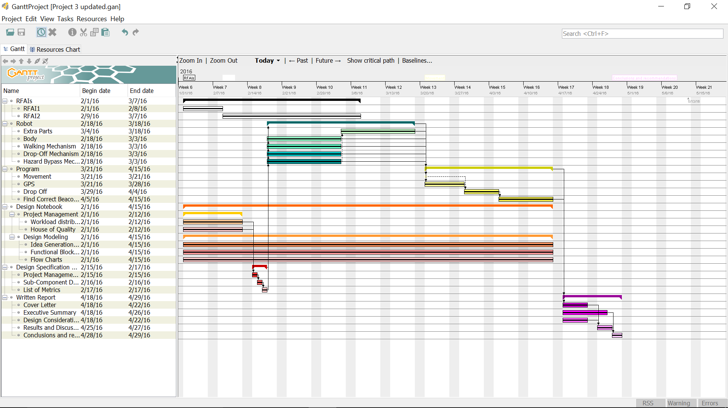

Workload Distribution -- Updated 2/15/2016

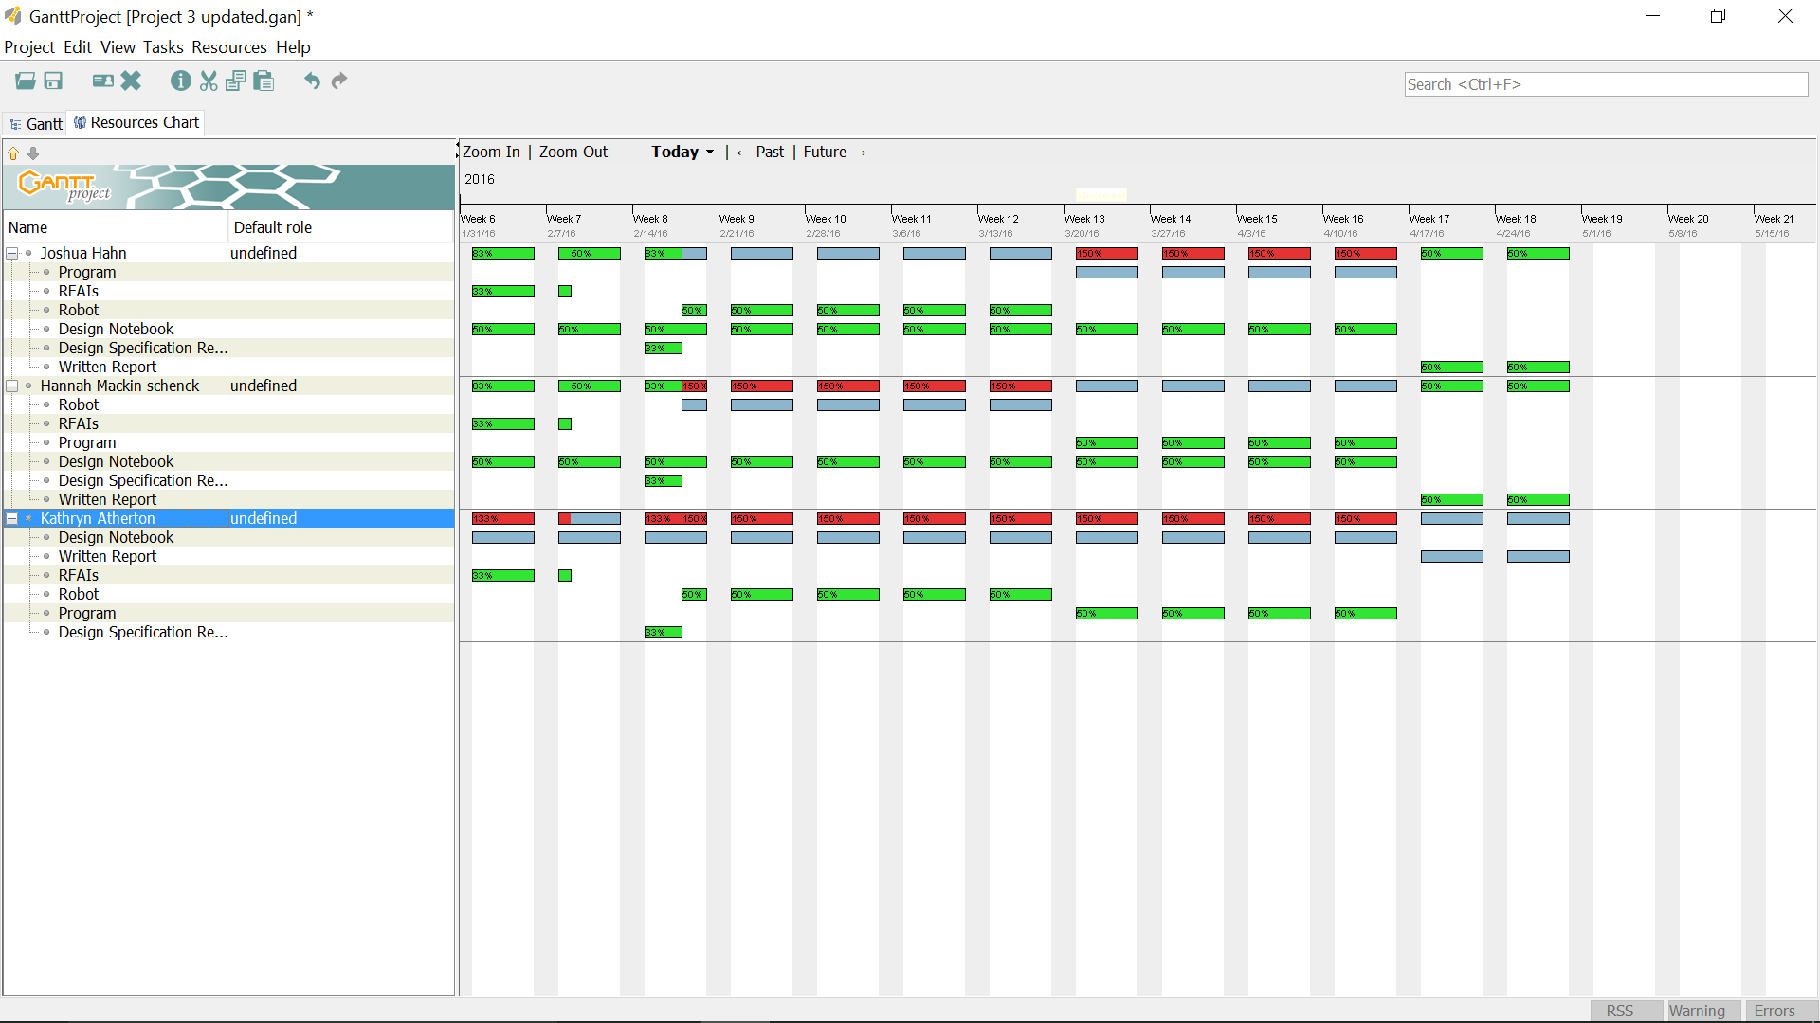

Work Breakdown Structure -- Updated 2/15/2016

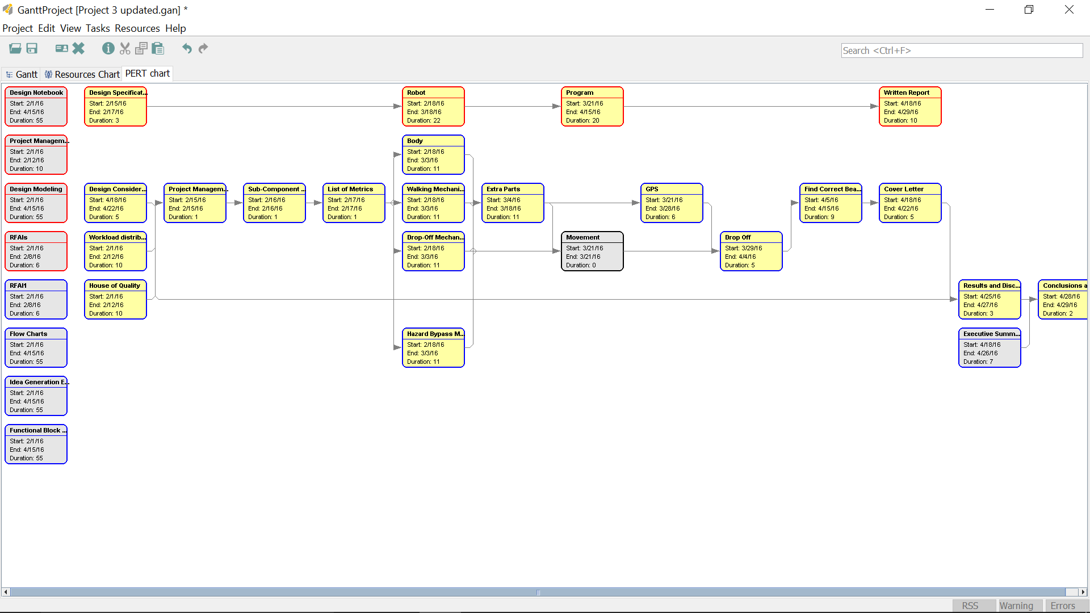

**BRAINSTORMING**

Morphological Chart -- Updated 2/14/2016

|  |  |  |  |
| --- | --- | --- | --- |
| **System** | **Means** | | |
| Body | Tank | Multi-wheel design |  |
| Wheels | treads | big wheels | small wheels |
| Drop-off system | bed with treads | separate container for each antenna |  |
| Drop-off location w/ respect to robot | behind | to the side(s) |  |
| Overcome obstacles | snow plow | drive over |  |

Design Specifications -- Updated April 6, 2016

|  |  |  |  |  |
| --- | --- | --- | --- | --- |
| **Customer Need** | **Technical Need** | **Technical Requirement** | **Target Value** | **Current Performance** |
| **TASK 1: MOBILITY IN OBSTACLE-FREE AREA** | | | | |
| Move quickly | Time to travel 1 foot in a straight line | Travels 1 foot in < 5 seconds | Travels 1 foot in < 2 seconds | Travels 1 foot in 0.5 second |
| Move straight | Travel to a specified location via a straight line and stop with marker over a specified point | Marker < 2 inches from point | Marker < 0.5 inches from point |  |
| Make tight turns | Turning radius -- radius of the smallest circular path the ALV can follow | Radius < 5 inches | Radius < 3 inches |  |
| Can follow a path that turns | Travel to a specified location via a path with at least 1 turn immediately before the location and stop with marker over a specified point | Marker < 2 inches from point | Marker < 0.5 inches from point |  |
| Move over a large distance | Minimum distance able to travel without breaking | Minimum distance > 20 feet | Minimum distance > 25 feet | Minimum distance > 6 feet |
| **TASK 2: NAVIGATE USING GPS SIGNAL/ SURROUNDING OBSTACLES** | | | | |
| Stops at a given destination | The ALV stops within a small distance of given location | Distance < 3 inches | Distance < 1 inch |  |
| Navigate around surrounding obstacles | Distance from edge of obstacle to edge of ALV while maneuvering around obstacle | Distance < 5 inches | Distance < 2 inches |  |
| Can estimate its current coordinates | Distance from where the robot is to where it thinks it is | Distance is less than 10 cm | Distance is less than 5 cm |  |
| Can estimate its current direction | Difference in degrees of where the robot is facing versus where it thinks it is facing | Degree difference is less than 30 degrees | Degree difference is less than 10 degrees |  |
| Can navigate along a straight path | Distance offset from a straight path 5 feet long | Distance < 5 inches | Distance < 2 inches |  |
| Can navigate around corners | Distance offset from a circular path of radius 3 feet | Distance < 5 inches | Distance < 2 inches |  |
| Can turn to face next checkpoint | Difference in angle between a randomly selected checkpoint and where the robot is facing after orienting itself | Angle < 10 degrees | Angle < 5 degrees |  |
| Troubleshoots if ALV runs into an obstacle it cannot overcome | Time to re-route around obstacles ALV cannot overcome | Time < 5 seconds | Time < 2 seconds |  |
| **TASK 3: ABILITY TO TRAVERSE SMALL OBSTACLES** | | | | |
| Overcome small hazards | Height of obstacle AVL able to overcome | Able to overcome obstacles of height > 10 mm | Able to overcome obstacles of height > 20 mm | Able to overcome obstacles of height > 6 mm |
| Move quickly to overcome hazards | Time to travel 1 foot while overcoming obstacle with maximum height 10 mm | Travels 1 foot < 5 seconds | Travels 1 foot < 2 second | Travels 1 foot in 0.5 seconds |
| Traverse a variety of obstacles and terrain | Time to travel 1 foot while traversing irregular terrain (squishy, slippery, rough, uphill, downhill, uneven, etc.) | Travels 1 foot < 5 seconds | Travels 1 foot < 2 second | Travels 1 foot in 0.5 seconds |
| **TASK 4: LOCATE BEACON AND STOP AT IT** | | | | |
| Locate and stop at beacon | Distance from the center of where antenna would be placed to the center of the beacon | Distance < 1 foot | Distance < 6 inches |  |
| Make known that a beacon location has been identified | Time to beep 3 times after correctly identifying (i.e. stopping at) a beacon | Time < 1 second | Time < 0.5 seconds |  |
| **TASK 5: TRANSPORT AND DROP ANTENNA IN PROPER ORIENTATION** | | | | |
| Can carry multiple antenna | Distance can walk fully loaded | Can walk at least 10 feet with 600 grams loaded onto the robot without falling over | Can walk at least 20 feet with 800 grams loaded onto the robot without falling over |  |
| Can place antenna close to drop point | Distance from a drop off point to the closest part of the box to drop off location | Can drop antenna off 0 inches away from the drop off point | Can drop antenna off 0 inches away from the drop off point |  |
| Can place antenna in proper orientation | Number of antenna that are placed with the correct side facing up | Can drop all 3 antenna in the correct orientation | Can drop all 3 antenna in the correct orientation | Drops 0 / 3 antenna in correct orientation |
| Can disengage | Distance the robot can move away from a drop off point after unloading an antenna package within 30 seconds | Can move 2 cm away from the antenna after unloading it | Can move 3 cm away from the antenna after unloading it | Can move 50 cm away from the antenna after unloading it |
| Does not drop antenna en route to destinations | Distance the ALV can travel without losing any antenna | Can travel at least 10 feet fully loaded without losing any antenna | Can travel at least 20 feet fully loaded without losing any antenna |  |
| **TASK 6: UTILIZE GPS TRACKING SOFTWARE** | | | | |
| Can display its current coordinates | Distance from where the robot is to where it thinks it is | Distance is less than 10 cm | Distance is less than 5 cm |  |
| Can recognize invalid coordinates | Time to recognize invalid coordinates | Time < 10 seconds | Time < 5 seconds |  |
| Can handle different types of errors | Errors ALV can handle | ALV can handle errors < 16 (i.e. 2, 4, 8) | ALV can handle errors >= 32 (i.e. 2, 4, 8, 16, 32) |  |
| Can determine its direction | Difference in degrees of where the robot is facing versus where it thinks it is facing | Degree difference is less than 30 degrees | Degree difference is less than 10 degrees |  |
| Can receive GPS coordinates | Time to receive and display GPS coordinates | Takes less than 10 seconds to receive and display the correct GPS coordinates | Takes less than 5 seconds to receive and display the correct GPS coordinates |  |

**PROTOTYPES**

PROTOTYPE I -- Created Feb. 16, 2016; Rejected February 16, 2016

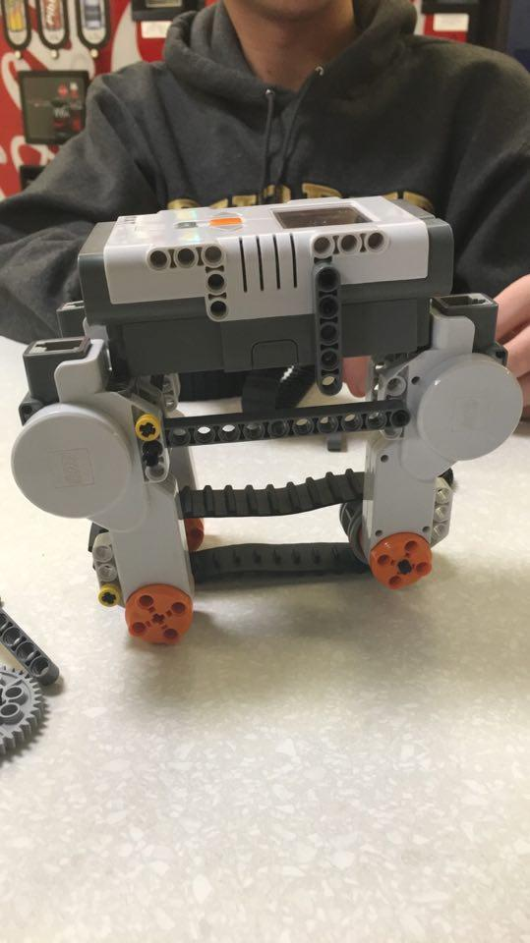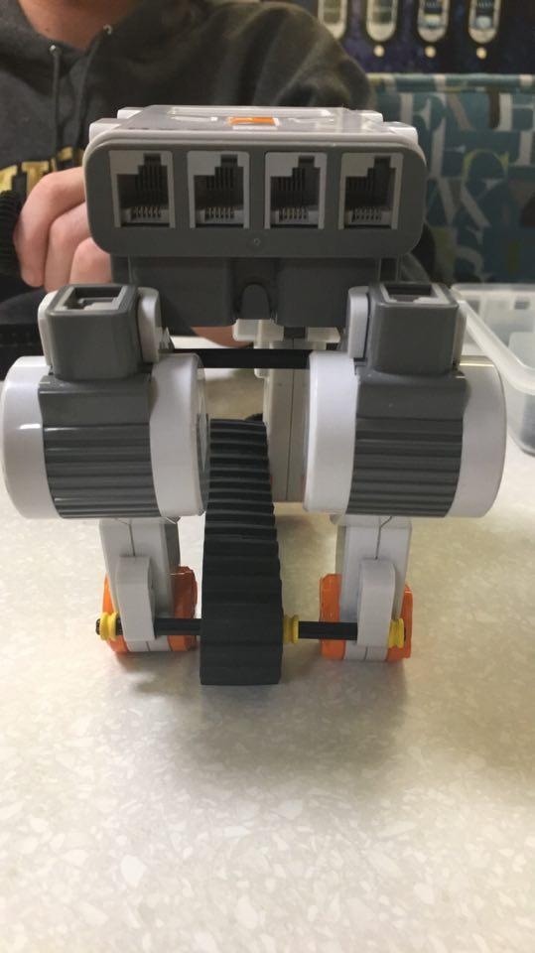

(left side view) (back view)

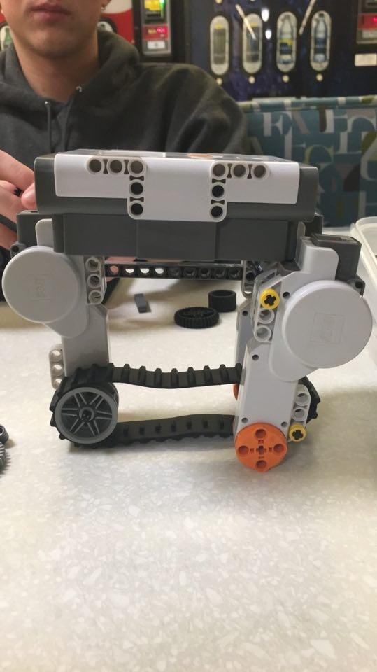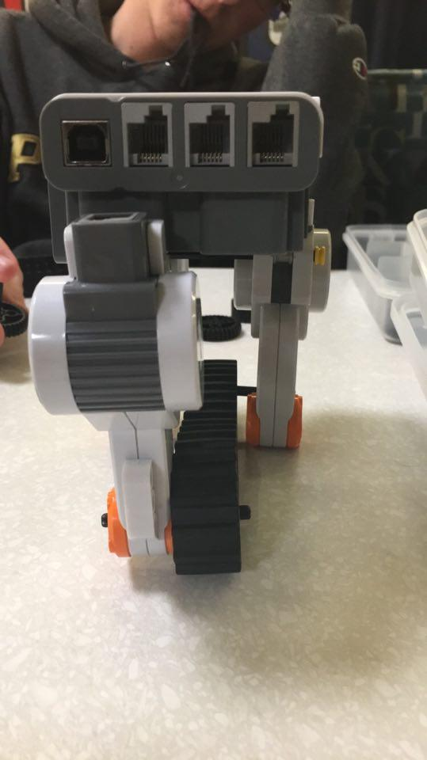

(right side view) (front view)

Explanation of Design:

This design was meant to incorporate the multi-wheel design with small wheels, a conveyor belt-style drop-off system, with the antenna being dropped off behind the ALV. The rationale behind the design was that the boxes would be protected within the body of the robot to prevent them from spilling out or getting damaged during landing and travel. This design was ultimately rejected, as the space above the conveyor belt just barely had enough space for the three antenna boxes, thus making the boxes prone to becoming stuck in the space when it was time to drop one off.

PROTOTYPE II -- Created February 16, 2016; Rejected --



(back view) (front view)



(side view) (top view)



(side view of slide)

Explanation of Design:

After the first design was rejected, a basic framework for an NXT robot was created based on the research done by the team. February 27, 2016, the team added a conveyor belt to the back in order to hold and drop off the antenna. March 8, 2016, the team added a cage to the back over the conveyor belt to hold and drop antenna. March 10, 2016, the team added a slide to the back behind the conveyor belt to control the dropping of the antenna.

**FLOWCHARTS AND QFDs**

Functional Block Diagram -- Updated March 13, 2016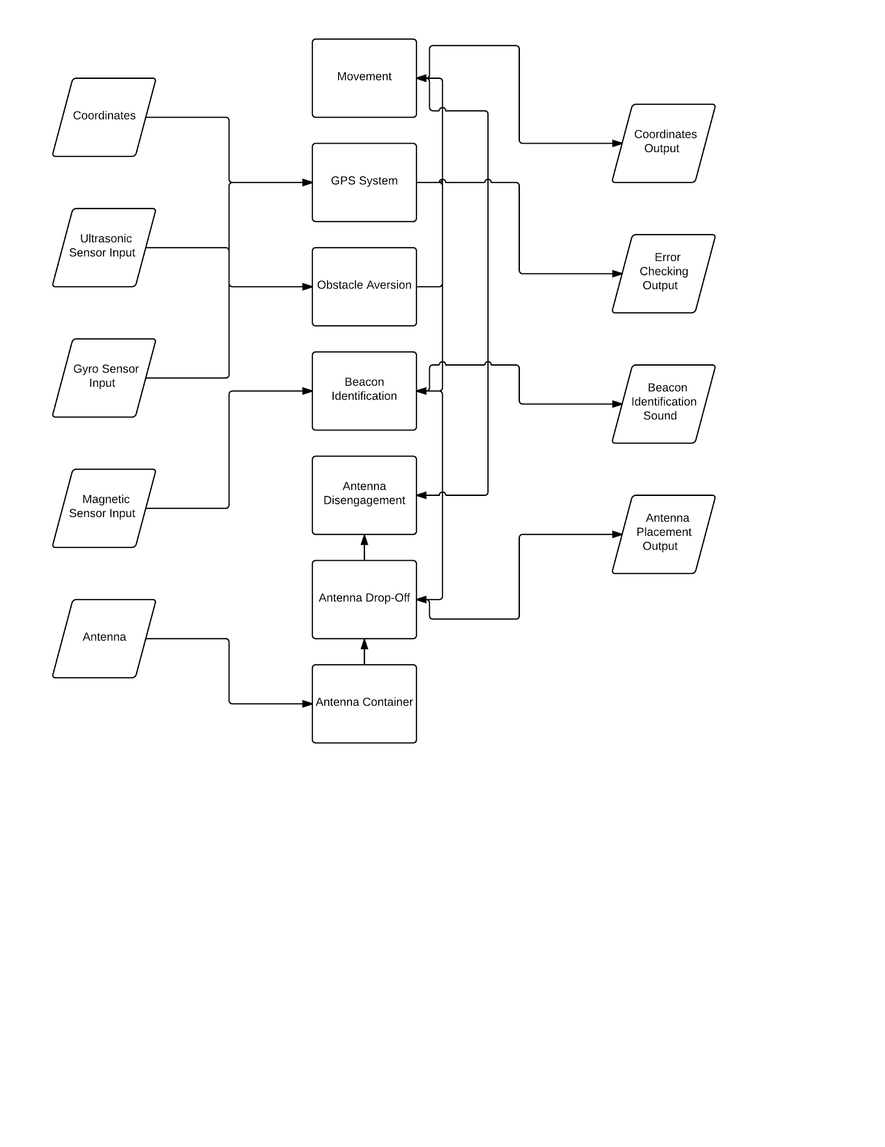

Code Logic Flowchart 1 -- Updated March 21, 2016

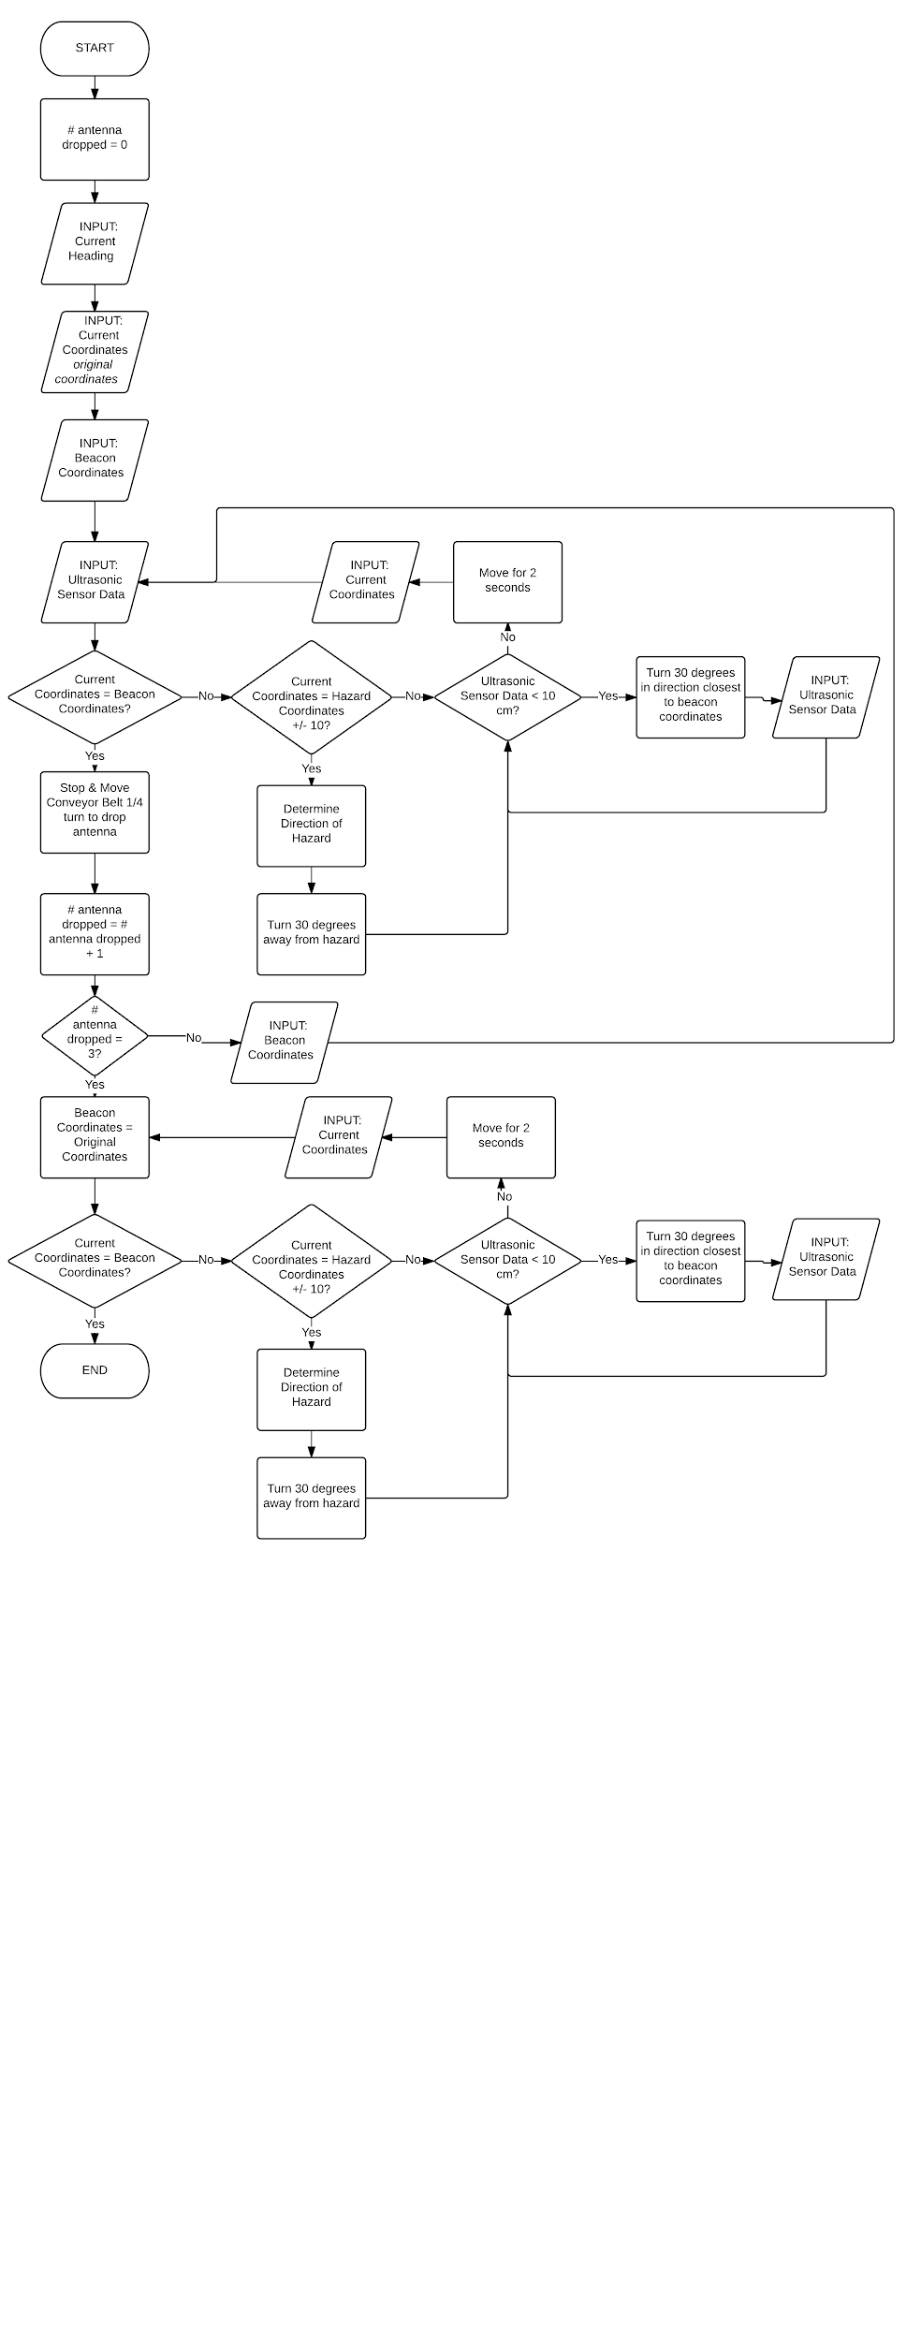

Code Logic Figure 2 -- Downsized Version of Final Map

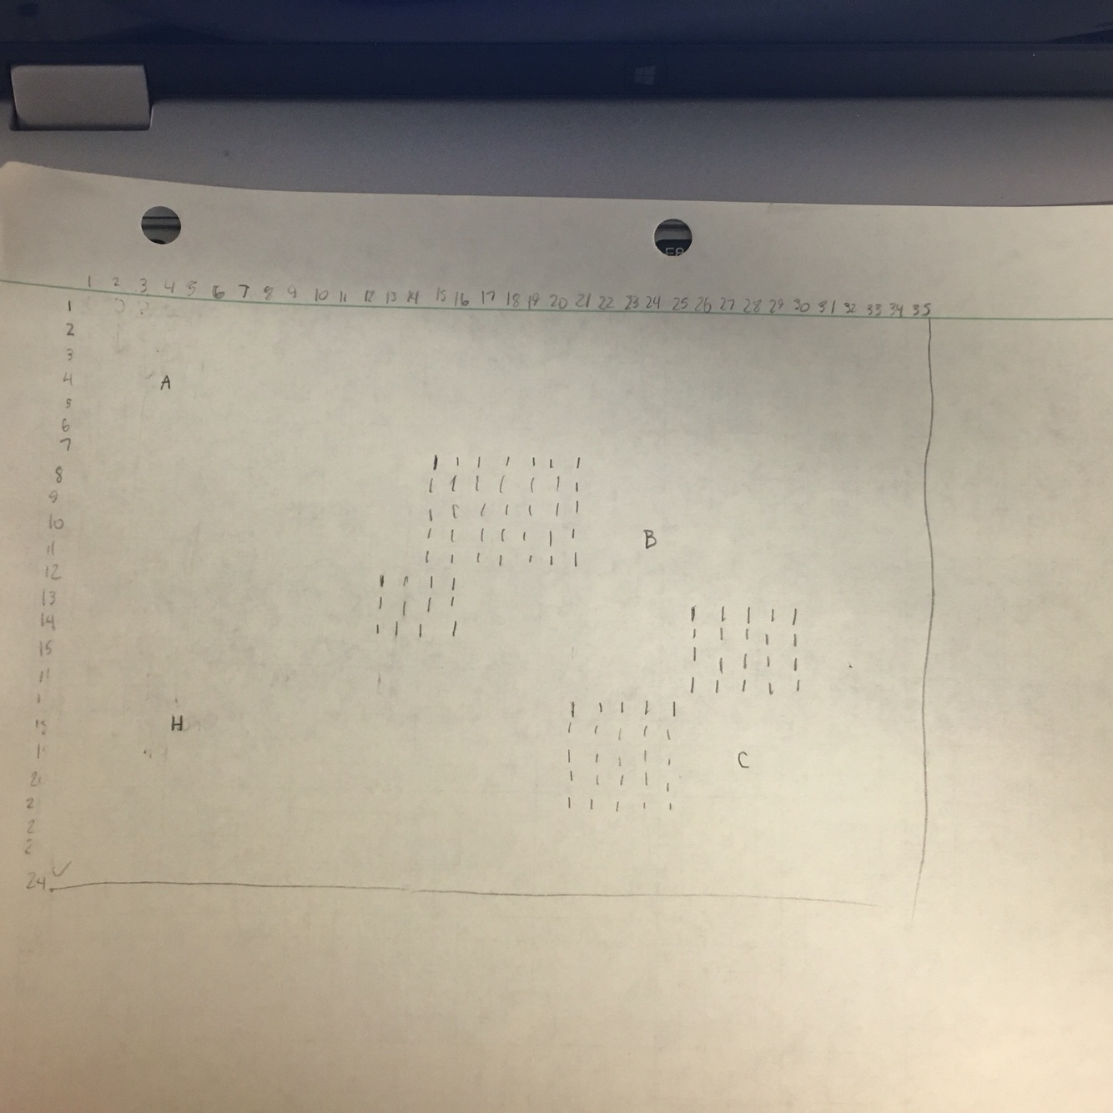

**EXPERIMENTS AND RESULTS**

POC 1 Testing -- Updated March 9, 2016

|  |  |  |  |
| --- | --- | --- | --- |
| TASK | DESCRIPTION | PASS/FAIL? | OBSERVATIONS |
| 1 | Move in an obstacle-free area after turning 30 degrees toward the intended path | PASS -- INTEGRATED WITH TASK 3 | The ALV turned and passed smoothly through the course |
| 2 | Navigate using GPS signal or surrounding obstacles | UNABLE TO ATTEMPT | N/A |
| 3 | Avoid/Traverse small obstacles | PASS -- INTEGRATED WITH TASK 1 | The ALV turned and passed smoothly over the obstacles |
| 4 | Locate a beacon and stop at it. Beep three times after stopping with the paperclip over the beacon | NOT ATTEMPTED | N/A |
| 5 | Transport and drop an antenna in proper orientation | FAIL | No matter the orientation of the block inside the ALV’s cage, it would never fall in the correct orientation --> need a way to control its fall |
| 6 | Utilize GPS tracking software | UNABLE TO ATTEMPT | N/A |

Total Score: 8 / 24

Dropping Orientation Testing -- Updated 4/10/2016

|  |  |  |  |  |  |  |
| --- | --- | --- | --- | --- | --- | --- |
| TESTING -- Desired Ending Orientation 1 |  |  |  | SLOWER MOTOR SPEED |  |  |
| Starting Orientation | Ending Orientation | Distance from Back of ALV (cm) |  | Starting Orientation | Ending Orientation | Distance from Back of ALV (cm) |
| 1 | 3 | 5.5 |  | 1 | 1 | 12 |
| 1 | 4 | 6.5 |  | 1 | 1 | 11 |
| 1 | 2 | 13.5 |  | 1 | 3 | 4 |
| 1 | 4 | 9 |  | 1 | 4 | 9 |
| 1 | 1 | 9 |  | 1 | 1 | 10 |
| 1 | 4 | 9 |  | 1 | 1 | 10 |
| 1 | 4 | 8 |  | 1 | 3 | 6.5 |
| 1 | 4 | 9 |  | 1 | 1 | 9.5 |
| 1 | 1 | 10 |  | 1 | 4 | 10 |
| 1 | 4 | 7 |  | 1 | 2 | 12 |
| 1 | 4 | 10 |  | 1 | 1 | 9.5 |
| Mode/Average | 4 | 8.772727273 |  | Mode/Average | 1 | 9.409090909 |

POC 2 Testing -- Updated March 14, 2016

|  |  |  |  |
| --- | --- | --- | --- |
| TASK | DESCRIPTION | PASS/FAIL? | OBSERVATIONS |
| 1 | Move in an obstacle-free area after turning 30 degrees toward the intended path | PASSED IN POC 1 -- INTEGRATED WITH TASK 3 | See POC 1 |
| 2 | Navigate using GPS signal or surrounding obstacles | NOT ATTEMPTED | N/A |
| 3 | Avoid/Traverse small obstacles | PASSED IN POC 1 -- INTEGRATED WITH TASK 1 | See POC 1 |
| 4 | Locate a beacon and stop at it. Beep three times after stopping with the paperclip over the beacon | FAIL | Robot kept missing the beacon; was unable to find the magnetic signal |
| 5 | Transport and drop an antenna in proper orientation | PASS | Dropped block in correct orientation after 2 tries--due to difference in weight from the actual blocks and the ones used in testing |
| 6 | Utilize GPS tracking software | NOT ATTEMPTED | N/A |

Total Score: 10 / 24

**DECISION MATRICES**

House of Quality (How vs. How) -- Updated March 14, 2016

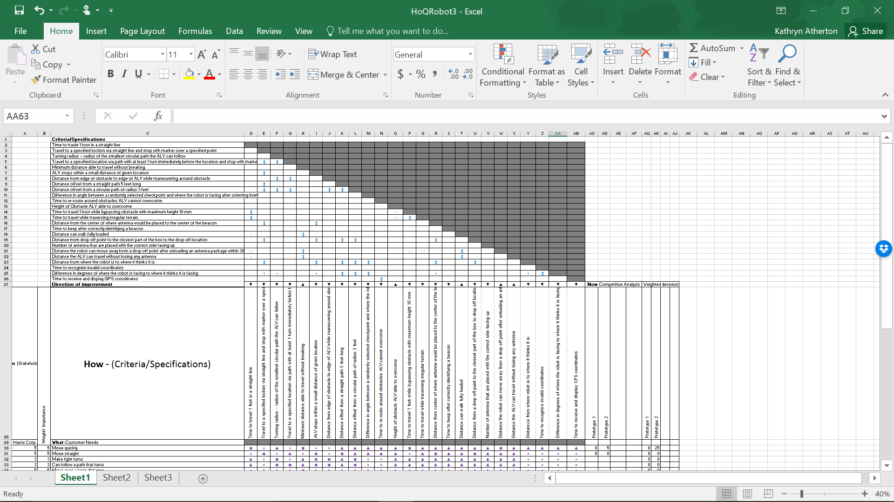

House of Quality (What vs. How (above)) -- Updated March 14, 2016

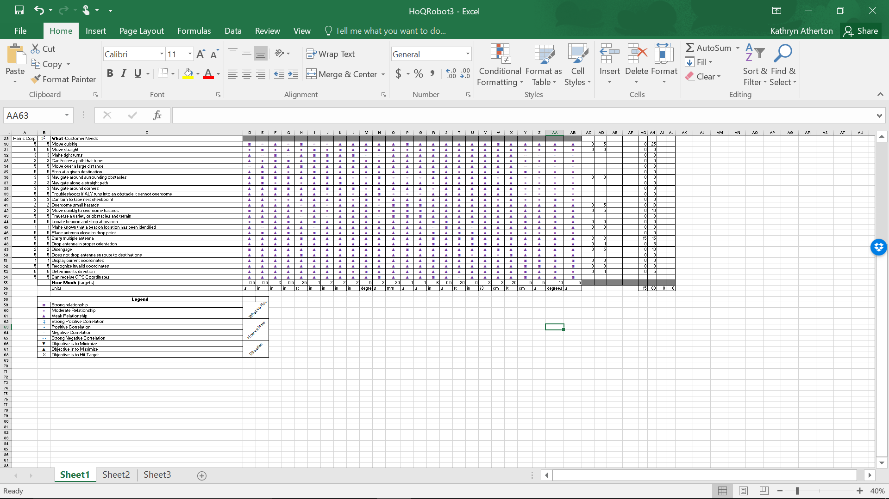

House of Quality (What vs. Now/Weighted Decision) -- Updated March 22, 2016